**Dharmsinh Desai University, Nadiad**

**Department of Information Technology**

**DAIE, IT704**

**B.Tech. IT, Sem: VII**

**Aim: - Create an application in which user has to display records in the Grid View Control from Table created in access data base.**

**Code: -**

1. **WebForm1.aspx**

<%@ Page Language="C#" AutoEventWireup="true" CodeBehind="WebForm1.aspx.cs" Inherits="Lab11.WebForm1" %>

<!DOCTYPE html>

<html xmlns="http://www.w3.org/1999/xhtml">

<head runat="server">

<title></title>

</head>

<body>

<form id="form1" runat="server">

<div>

<asp:GridView runat="server" ID="GridView1" AllowPaging="True" AllowSorting="True" AutoGenerateColumns="False" BackColor="White" BorderColor="#CCCCCC" BorderStyle="None" BorderWidth="1px" CellPadding="4" DataKeyNames="Emp_Id" DataSourceID="SqlDataSource1" ForeColor="Black" GridLines="Horizontal">

<Columns>

<asp:CommandField ShowDeleteButton="True" ShowEditButton="True" ShowSelectButton="True" />

<asp:BoundField DataField="Emp_Id" HeaderText="Emp_Id" InsertVisible="False" ReadOnly="True" SortExpression="Emp_Id" />

<asp:BoundField DataField="Emp_name" HeaderText="Emp_name" SortExpression="Emp_name" />

<asp:BoundField DataField="Emp_salary" HeaderText="Emp_salary" SortExpression="Emp_salary" />

<asp:BoundField DataField="Emp_conutry" HeaderText="Emp_conutry" SortExpression="Emp_conutry" />

<asp:BoundField DataField="Emp_department" HeaderText="Emp_department" SortExpression="Emp_department" />

</Columns>

<FooterStyle BackColor="#CCCC99" ForeColor="Black" />

<HeaderStyle BackColor="#333333" Font-Bold="True" ForeColor="White" />

<PagerStyle BackColor="White" ForeColor="Black" HorizontalAlign="Right" />

<SelectedRowStyle BackColor="#CC3333" Font-Bold="True" ForeColor="White" />

<SortedAscendingCellStyle BackColor="#F7F7F7" />

<SortedAscendingHeaderStyle BackColor="#4B4B4B" />

<SortedDescendingCellStyle BackColor="#E5E5E5" />

<SortedDescendingHeaderStyle BackColor="#242121" />

</asp:GridView>

<asp:SqlDataSource ID="SqlDataSource1" runat="server" ConnectionString="<%$ ConnectionStrings:ConnectionString %>" DeleteCommand="DELETE FROM [Employee] WHERE [Emp_Id] = @Emp_Id" InsertCommand="INSERT INTO [Employee] ([Emp_name], [Emp_salary], [Emp_conutry], [Emp_department]) VALUES (@Emp_name, @Emp_salary, @Emp_conutry, @Emp_department)" SelectCommand="SELECT * FROM [Employee]" UpdateCommand="UPDATE [Employee] SET [Emp_name] = @Emp_name, [Emp_salary] = @Emp_salary, [Emp_conutry] = @Emp_conutry, [Emp_department] = @Emp_department WHERE [Emp_Id] = @Emp_Id" >

<DeleteParameters>

<asp:Parameter Name="Emp_Id" Type="Int32" />

</DeleteParameters>

<InsertParameters>

<asp:Parameter Name="Emp_name" Type="String" />

<asp:Parameter Name="Emp_salary" Type="Decimal" />

<asp:Parameter Name="Emp_conutry" Type="String" />

<asp:Parameter Name="Emp_department" Type="String" />

</InsertParameters>

<UpdateParameters>

<asp:Parameter Name="Emp_name" Type="String" />

<asp:Parameter Name="Emp_salary" Type="Decimal" />

<asp:Parameter Name="Emp_conutry" Type="String" />

<asp:Parameter Name="Emp_department" Type="String" />

<asp:Parameter Name="Emp_Id" Type="Int32" />

</UpdateParameters>

</asp:SqlDataSource>

<br />

<asp:DetailsView ID="DetailsView1" runat="server" AutoGenerateRows="False" BackColor="White" BorderColor="#CCCCCC" BorderStyle="None" BorderWidth="1px" CellPadding="4" DataKeyNames="Emp_Id" DataSourceID="SqlDataSource2" ForeColor="Black" GridLines="Horizontal" Height="50px" Width="125px">

<EditRowStyle BackColor="#CC3333" Font-Bold="True" ForeColor="White" />

<Fields>

<asp:BoundField DataField="Emp_Id" HeaderText="Emp_Id" InsertVisible="False" ReadOnly="True" SortExpression="Emp_Id" />

<asp:BoundField DataField="Emp_name" HeaderText="Emp_name" SortExpression="Emp_name" />

<asp:BoundField DataField="Emp_salary" HeaderText="Emp_salary" SortExpression="Emp_salary" />

<asp:BoundField DataField="Emp_conutry" HeaderText="Emp_conutry" SortExpression="Emp_conutry" />

<asp:BoundField DataField="Emp_department" HeaderText="Emp_department" SortExpression="Emp_department" />

<asp:CommandField ShowDeleteButton="True" ShowEditButton="True" ShowInsertButton="True" />

</Fields>

<FooterStyle BackColor="#CCCC99" ForeColor="Black" />

<HeaderStyle BackColor="#333333" Font-Bold="True" ForeColor="White" />

<PagerStyle BackColor="White" ForeColor="Black" HorizontalAlign="Right" />

</asp:DetailsView>

<asp:SqlDataSource ID="SqlDataSource2" runat="server" ConnectionString="<%$ ConnectionStrings:ConnectionString %>" DeleteCommand="DELETE FROM [Employee] WHERE [Emp_Id] = @Emp_Id" InsertCommand="INSERT INTO [Employee] ([Emp_name], [Emp_salary], [Emp_conutry], [Emp_department]) VALUES (@Emp_name, @Emp_salary, @Emp_conutry, @Emp_department)" SelectCommand="SELECT * FROM [Employee] WHERE ([Emp_Id] = @Emp_Id2)" UpdateCommand="UPDATE [Employee] SET [Emp_name] = @Emp_name, [Emp_salary] = @Emp_salary, [Emp_conutry] = @Emp_conutry, [Emp_department] = @Emp_department WHERE [Emp_Id] = @Emp_Id">

<DeleteParameters>

<asp:Parameter Name="Emp_Id" Type="Int32" />

</DeleteParameters>

<InsertParameters>

<asp:Parameter Name="Emp_name" Type="String" />

<asp:Parameter Name="Emp_salary" Type="Decimal" />

<asp:Parameter Name="Emp_conutry" Type="String" />

<asp:Parameter Name="Emp_department" Type="String" />

</InsertParameters>

<SelectParameters>

<asp:ControlParameter ControlID="GridView1" Name="Emp_Id2" PropertyName="SelectedValue" Type="Int32" />

</SelectParameters>

<UpdateParameters>

<asp:Parameter Name="Emp_name" Type="String" />

<asp:Parameter Name="Emp_salary" Type="Decimal" />

<asp:Parameter Name="Emp_conutry" Type="String" />

<asp:Parameter Name="Emp_department" Type="String" />

<asp:Parameter Name="Emp_Id" Type="Int32" />

</UpdateParameters>

</asp:SqlDataSource>

</div>

</form>

</body>

</html>

**Output: -**

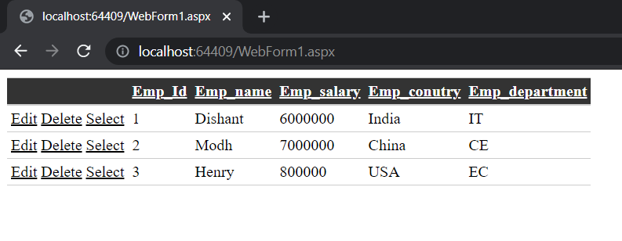

Fig. 1 Basic GUI

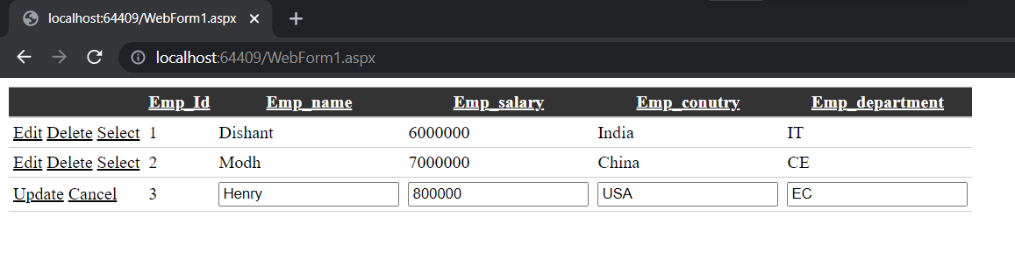

Fig. 2 Editing Data

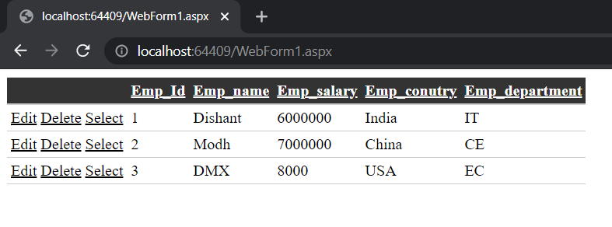

Fig. 3 Updated Database

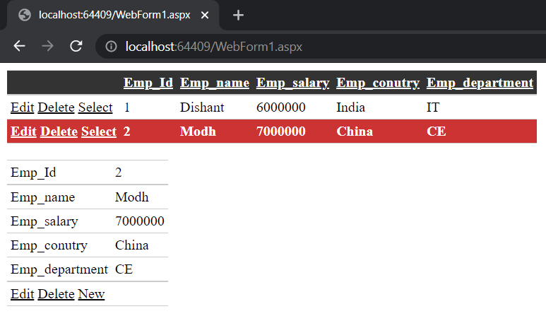

Fig. 4 Selecting data

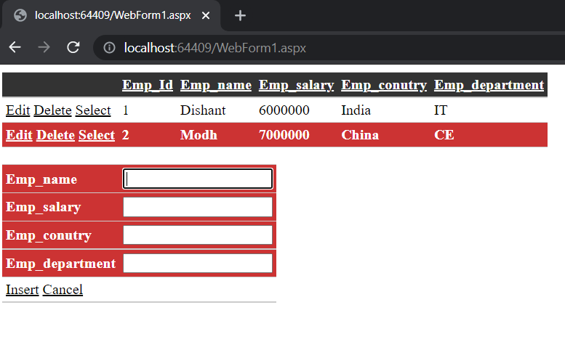

Fig. 5 Adding New Data Database